Building Sustainable Livelihoods
for Women and Youth Affected By Mining

Establishment of the Women and Youth Vocational Education Center in Liberia

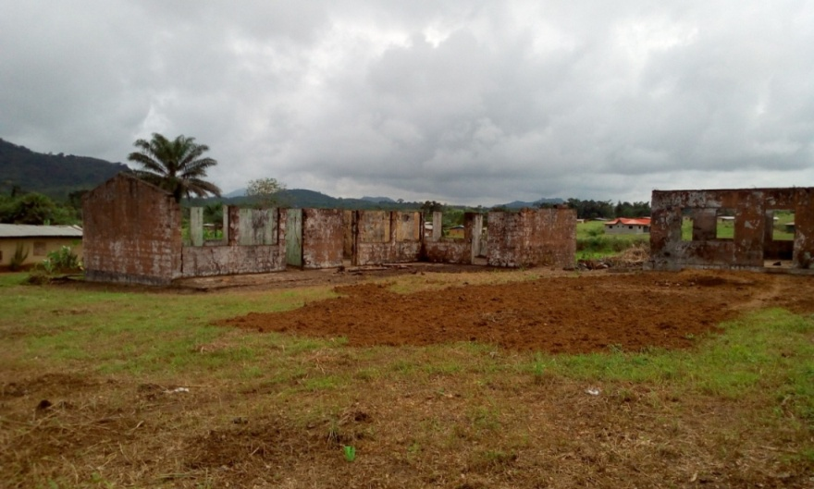
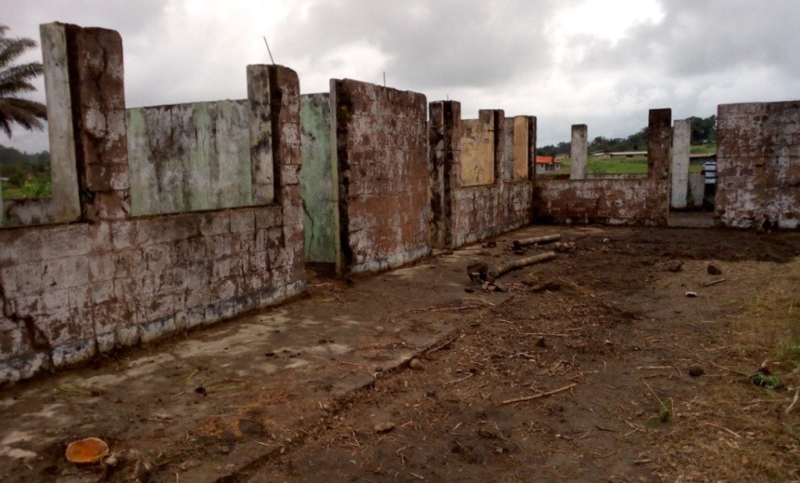

An Application for Funding

Name of Our Organization:
Committee for Peace and Development Advocacy - Sweden (COPDA Sweden)

Website:
www.copdasweden.org

Contact:
Name: Ann Huber
Phone:
Email: annhuber1961@gmail.com

Short Text on Organization:

Objectives:
- To develop and design programs to support business, academic and vocational education;
- To conduct research and undertake projects for development assistance and cooperation to address and alleviate poverty; and
- To strengthen initiatives to promote human rights, peace and peaceful coexistence.

Size:
- 47 active organisational members (57 donors for our scholarship program)
- 9 staff (includes 2 volunteers)

Established When and Where:
- Established 2014 in Stockholm, Sweden

Name of the Project:
Building Sustainable Livelihoods for Women and Youth Affected by Mining

Brief Description of the Project (Mentioning Project Partners)

Nearly 2,000 youths and women within grassroots mining communities in Liberia are facing serious challenges. Key among the challenges is poor livelihood with little or no access to employment.

To help address these challenges, COPDA Sweden will partner with COPDA, Inc. (Liberia) and the CDMC (Community Development Management Committee), as project partners. The CDMC is a registered network of women groups advocating for livelihood benefits within mine-affected communities of Nimba. Under this partnership, COPDA Sweden will establish and operate the Women and Youth Vocational Education Center which will be located in Yekepa, Nimba County, Liberia.

The objectives of this project are to:

- Foster self employment among women and youths at the community level;
- Promote increased economic activities for improved livelihood, and
- Reduce the level of juvenile delinquency among youths.

This project seeks funding to undertake work in two phases. Phase I is the renovation of the Vocational Training Center. COPDA will renovate an existing structure to jumpstart the vocational education program. The building is a former school building which has not been used over the years and was partly repaired through voluntary assistance from COPDA Sweden. Phase II is the implementation of the actual vocational training program.

Under a two-year program, COPDA Sweden will target, recruit and train 300 women and youths to acquire specialised vocational skills. The training will be carried out in cycles and will consist of theoretical and practical lessons based on a specialized training curriculum approved by the Ministry of Education, Liberia. Daily class schedule will begin 9am and end by 4pm.

Adult Literacy and Financial/Business Literacy Teaching:
Along with the vocational training, COPDA Sweden will conduct an adult literacy program for trainees enrolled under the vocational education program. The adult literacy program will provide basic reading and writing knowledge to trainees and will help strengthen their reading and writing skills. As part of the literacy education, COPDA Sweden will include Business/Financial Literacy under this program to enable beneficiaries understand simple Mathematics and the basics of Financial Management. COPDA Sweden has developed a curriculum, and will hire the services of a trained instructor.

The training will be basically tailored to meet the needs of our target to provide knowledge and understanding as follows:

Literacy Training | Financial Literacy | Business Planning and Dev.
- Basic reading and writing;  - Simple English;  - Simple Mathematics; | - Identification of Financial Data;  - Computing Financial data;  - Simple Multiplication and Division for Financial Transactions; | - Managing Records;  - Developing Business Plans;  - Financial Projections;

COPDA Sweden, along with partners, will recruit and hire locally qualified trainers who will provide training in the following three (3) vocational training courses under the Women and Youth Vocational Education Center:

Training Courses to be Offered
- Tailoring
- Animal Husbandry
- Soap Making

Training Plan:

Training Courses | Number of Trainees Targeted
 | Cycle 1  6-Month Duration | Cycle 2  6-Month Duration | Cycle 3  6-Month Duration | Cycle 4  6-Month Duration
Soap Making | 25 | 25 | 25 | 25
Tailoring | 25 | 25 | 25 | 25
Animal Husbandry | 25 | 25 | 25 | 25
Total Targeted: 300 Trainees

Sustainability of Beneficiaries/Employment Potential of Project:
COPDA Sweden, in cooperation with partners in Liberia, will produce a solid sustainability plan through which all trainees upon successful completion of training will be absorbed to gain full employment.

Upon successful completion of training, COPDA Sweden will officially graduate successful trainees and present each successful trainee with a certificate and a starter package. The package will comprise one set of the basic tools, materials and equipment for each course which is intended for trainees to work and produce independently. For example, trainees who successfully graduate in Tailoring will be presented with a sewing machine, some cloth and accessories which will enable him/her to jumpstart a tailoring business.

With the support of our partners in Liberia, COPDA Sweden will organize and set up a Business Cooperative to be registered under the laws of Liberia. Upon graduation, the Business Cooperative will register and admit trainees who have successfully completed training to become members of the cooperative. With the training package provided, each trainee will work as a full member of the cooperative, produce and market their products to the public. The cooperative will be legally registered and will enter into service contracts with potential vendors such as the mining company, non-governmental organisations and other entities. The cooperative will produce and market their products and do business with any group or individual.

The diagram below explains the process leading to employment under this project:

Stage IV
PRODUCTION & MARKETING

(Enterprise Development & Employment)
Stage III
BUSINESS COOPERATIVE

(Registration and Membership)
Stage II
GRADUATION FOR SUCCESSFUL TRAINEES

(Certification & Presentation of Starter Package)
Stage I
WOMEN AND YOUTH VOCATIONAL EDUCATION CENTER

(Skills Training)

COPDA Sweden, through our partners COPDA Liberia and the CDMC, will be responsible to manage the Business Cooperative in collaboration with the community leadership, and will regularly monitor and report on the work of the Business Cooperative. This is to ensure that employment is sustained at the community level and all those who receive training are part of the cooperative and engaged in functional business activities.

Total Project Budget:
$ 41,000

Overview of Funds/current applications for this project (mentioning the budget deficit)

Total Project Budget  (Expressed in US Dollars) | $ 41,000
Total Requested from Donor | $ 41,000
Current Applications for this Project | $ 0
Budget Deficit | ($ 0 )

Appendix:

TOTAL PROJECT BUDGET
(Expressed in US Dollars)

PHASE I: Renovation of Building, Clearing and Landscaping
No. | Description | Quantity | Unit  Price | Total
1.0 | CARPENTRY: ROOFING AND CEILING INSTALLATION
1.1 | Bundles Zinc (24’ gauge) | 26 Bundles | $ 95.00 | $ 2,470.00
1.2 | Packs Wire Nails (4’) | 150 PKS | $ 0.50 | 75.00
1.3 | Packs Wire Nails (3’) | 100 PKS | $ 0.50 | 50.00
1.4 | Packs Wire Nails (1’) | 30 PKS | $ 0.50 | 15.00
1.5 | Packs Wire Nails (0.5’) | 18 PKS | $ 0.50 | 9.00
1.6 | Packs Zinc Nails | 27 PKS | $ 3.50 | 94.50
1.7 | Bundles Wood Strips | 13 Bundles | $ 6.50 | 45.50
1.8 | Pieces Ceiling Boards | 76 PCS | $ 5.00 | 380.00
 | Sub Total: |  |  | $ 3,139.00
 | Wood:
1.2.1 | Pieces Timber (2 x 6) | 64 PCS | $ 4.50 | 288.00
1.2.2 | Pieces Timber (2 x 4) | 106 PCS | $ 2.50 | 265.00
1.2.3 | Pieces Timber (2 x 2) | 177 PCS | $ 1.20 | 212.40
1.2.4 | Pieces Timber (1 x 8) | 47 PCS | $ 4.50 | 211.50
 | Sub Total: |  |  | $ 976.90
 | Doors:
1.3.1 | Panel Doors (For each room) | 7 PCS | $ 60 | 420.00
 | Sub Total: |  |  | $ 420.00
 | Workmanship and Feeding:
1.4.1 | Negotiated Cost |  |  | $ 1,000.00
 | TOTAL ROOFING AND CEILING INSTALLATION: |  |  | $ 5,535.90
2.0 | MASONRY: RECONSTRUCTION OF WALLS, ROOMS, CONSTRUCTION OF WINDOWS, PAVEMENT AND FLOORS
2.1 | Bags Cement | 160 Bags | $ 10.00 | $ 1,600.00
2.2 | Bags White Cement | 10 Bags | $ 15.00 | 150.00
2.3 | Loads River sand | 26 Loads | $ 11.00 | 286.00
2.4 | Set Slide Glass Windows | 6 Sets | $ 220.00 | 660.00
2.5 | Packs Floor Tiles | 40 Packs | $ 18.00 | 720.00
2.6 | Air conditioning Split Units | 2 Units | $ 350.00 | 700.00
 | Sub Total
2.1.1 | Workmanship and Feeding:
 | Negotiated Cost |  |  | $ 1,000.00
 | TOTAL MASONRY RECONSTRUCTION AND CONSTRUCTION: |  |  | $5,116.00
3.0 | CONSTRUCTION OF TOILET FACILITIES:
3.1 | Bags Cement | 80 Bags | $10.00 | $ 800.00
3.2 | Pieces Steel Rods | 10 Pieces | $10.00 | 100.00
3.3 | Bundles Tie Wire | 1 Bundle | $ 7.50 | 7.50
3.4 | Packs Steel Nails (4”) | 4 Packs | $ 1.25 | 5.00
3.5 | Packs Steel Nails (3”) | 3 Packs | $ 0.50 | 1.50
3.6 | Pieces Timber (2 x 4) | 4 Pieces | $ 2.50 | 10.00
3.7 | Pieces Timber (2 x 2) | 8 Pieces | $ 1.20 | 9.60
3.8 | Pieces Timber (1 x 12) | 10 Pieces | $ 3.70 | 37.00
 | Sub Total: |  |  | $ 970.60
 | Plumbing:
3.1.1 | Piece Commode | 1 Each | $45.00 | $ 45.00
3.1.2 | Pieces Elbow | 8 Each | $ 3.00 | 24.00
3.1.3 | Pieces Teeth | 7 Each | $ 3.50 | 24.50
3.1.4 | Pieces Pipes | 4 Each | $10.50 | 42.00
3.1.5 | Piece Fortifier for Commode | 1 Each | $ 12.00 | 12.00
3.1.6 | Tins PVC Glue | 2 Tins | $ 3.50 | 7.00
3.1.7 | Packs Floor Tiles | 13 Packs | $13.00 | 169.00
3.1.8 | Gallon Cleaner (Cleaning Agent) | 1 Gallon | $10.00 | 10.00
3.1.9 | Pieces Saw blades | 4 Each | $ 1.50 | 6.00
3.2.1 | Bags White Cement | 2 Each | $15.00 | 30.00
 | Sub Total: |  |  | $ 369.50
 | Workmanship and Feeding:
 | Negotiated Cost |  |  | $ 400.00
 | TOTAL CONSTRUCTION OF TOILET: |  |  | $ 1,740.10
4.0 | PAINTING OF BUILDING
4.1 | Tins Oil Paint | 12 Tins | $75.00 | $ 900.00
4.2 | Tins Water Paint | 6 Tins | $45.00 | 270.00
4.3 | Gallons Thinner | 5 Gallons | $ 10.00 | 50.00
4.4 | Tins Putty | 2 Tins | $75.00 | 150.00
4.5 | Pieces Brush | 4 Each | $ 2.50 | 10.00
4.6 | Pieces Roller | 4 Each | $ 3.00 | 12.00
4.7 | Pieces Scraper | 4 Each | $ 2.50 | 10.00
4.8 | Packs Steel Nails (4”) | 4 Packs | $ 1.25 | 5.00
4.9 | Packs Steel Nails (3”) | 3 Packs | $ 0.50 | 1.50
 | Sub Total:
 | Workmanship and Feeding:
 | Negotiated Cost |  |  | $ 300.00
 | TOTAL PAINTING: |  |  | $1,708.50
5.0 | ELECTRICAL WORKS AND INSTALLATION OF FIXTURES:
 | Single Wire:
5.1 | Rolls Wire (4mm sq., Blue) | 6 Rolls | $ 45.00 | $ 270.00
5.2 | Rolls Wire (4mm sq., Black) | 6 Rolls | $ 45.00 | 270.00
5.3 | Rolls Wire (4 mm sq., Green/Yellow) | 3 Rolls | $ 45.00 | 105.00
5.4 | Rolls Wire (2.5mm sq., Blue) | 5 Rolls | $ 35.00 | 175.00
5.5 | Rolls Wire (2.5 mm sq., Black) | 5 Rolls | $ 35.00 | 175.00
5.6 | Rolls Wire (2.5 mm. sq., Green/Yellow) | 1 Roll | $ 35.00 | 35.00
 | Socket:
5.7 | Pieces for Administrative Office | 4 EA | $ 1.50 | $ 6.00
5.8 | Pieces for Computer Lab | 4 EA | $ 1.50 | 6.00
5.9 | Pieces for Classroom #1 | 4 EA | $ 1.50 | 6.00
5.1.1 | Pieces for Classroom #2 | 6 EA | $ 1.50 | 9.00
5.1.2 | Pieces for Classroom #3 | 6 EA | $ 1.50 | 9.00
5.1.3 | Pieces for Hallway | 6 EA | $ 1.50 | 9.00
5.1.4 | Pieces for Eve | 6 EA | $ 1.50 | 9.00
 | Outlet:
5.1.5 | Pieces double outlets with switch | 24 PCS | $ 4.00 | $ 96.00
 | Switches:
5.1.6 | Pieces Single Pole switch | 5 PCS | $ 4.00 | $ 20.00
5.1.7 | Pieces Double Pole switch | 2 PCS | $ 14.00 | 28.00
 | Accessories:
5.1.8 | Pack Phillip Screws | 1 Pack | $ 4.00 | $ 4.00
5.1.9 | Pieces Super Tape (33 + 10) | 4 PCS | $ 1.50 | 6.00
5.2.1 | Pieces Conduits (1.5”) | 60 PCS | $ 1.50 | 90.00
5.2.2 | Pieces Circuit Breaker (HAVELL 5 Amps) | 5 PCS | $ 5.00 | 25.00
5.2.3 | Pieces Circuit Breaker (HAVELL 10 Amps) | 5 PCS | $ 5.00 | 25.00
5.2.4 | Pieces Circuit Breaker (HAVELL 15 Amps) | 3 PCS | $ 5.00 | 15.00
5.2.5 | Pieces Circuit Breaker (HAVELL 20 Amps) | 2 PCS | $ 5.00 | 10.00
5.2.6 | Piece Mains Breaker (63 Amps, 3 Poles) | 1 PC | $ 10.00 | 10.00
5.2.7 | Piece Circuit Breaker Panel Box (HAVELL) | 1 PC | $ 30.00 | 30.00
5.2.8 | Pieces Junction Cups | 10 PCS | $ 3.00 | 30.00
5.2.9 | Piece Lightning Rod | 1 PC | $ 25.00 | 25.00
 | Sub Total: |  |  | $ 1,498.00
 | Workmanship and Feeding:
 | Negotiated Cost |  |  | $ 900.00
 | TOTAL ELECTRICAL WORKS, INSTALLATION OF FIXTURES: |  |  | $ 2,398.00
6.0 | Clearing and Landscaping of Project Site |  |  | $ 1,000.00
 | TOTAL COST |  |  | $ 17,498.50
 | Project Supervision and Transportation (9.42%) |  |  | 1,649.50
 | TOTAL PROJECT COST Phase I |  |  | $ 19,148.00

PHASE II: Administration of Basic Skills Training
 |  | Quantity | Unit  Cost | TOTAL
1.0 | Staff Costs
 | Training Program Coordinator | 6 Months | $200 | $ 1,200
 | Trainers (3) | 6 Months | $150 | 2,700
 | Instructor, Adult/Financial Literacy | 6 Months | $150 | 900
 | Maintenance Assistant/Cleaner | 6 Months | $100 | 600
 | Security | 6 Months | $100 | 600
 | Total Staff: |  |  | $ 6,000
2.0 | Training Materials
 | Tailoring:
 | Sewing Machines (SINGER) | 20 PCS | $200.00 | $ 4,000.00
 | Lappas | 36 PCS | $ 3.50 | 126.00
 | Scissors | 36 EA | $ 1.00 | 36.00
 | Thread | 96 EA | $ 1.00 | 96.00
 | Tapelines | 24 EA | $ 0.50 | 12.00
 | Machine Needles | 36 PKS | $ 1.00 | 36.00
 | Machine Oil | 24 EA | $ 1.50 | 36.00
 | Assorted Needles | 36 PKS | $ 1.00 | 36.00
 | Stiffing | 50 Yards | $ 1.00 | 50.00
 | Poplin | 50 Yards | $ 1.50 | 75.00
 | Zippers (Long/Short) | 100 EA | $ 0.30 | 30.00
 | Straight Pins | 36 PKS | $ 1.50 | 54.00
 | Buttons (Assorted) | 36 PKS | $ 1.50 | 54.00
 | Total Tailoring |  |  | $ 4,641.00
 | Soap Making:
 | Caustic Soda | 30 Bags | $ 36.00 | $ 1,080.00
 | Oil | 5 Tins | $ 20.00 | 100.00
 | Tubs (Plastic) | 24 PCS | $ 4.00 | 96.00
 | Buckets (Plastic) | 24 PCS | $ 3.00 | 72.00
 | Cutting Tables | 2 EA | $ 20.00 | 40.00
 | Gloves | 24 EA | $ 0.50 | 12.00
 | Cups | 6 EA | $ 0.50 | 3.00
 | Spoons | 6 EA | $ 0.50 | 3.00
 | Total Soap Making: |  |  | $ 1,406.00
 | Agriculture (Animal Husbandry):
 | Animals (Goats, Chickens, Pigs) | Assorted |  | $ 500.00
 | Chicken/Pig Feed | 30 Bags | $ 25.00 | 750.00
 | Construction of Animals Shelters |  |  | 500.00
 | Total Animal Husbandry: |  |  | $ 1,750.00
 | Adult Learning:
 | Text Books |  |  | $ 700.00
 | Notebooks |  |  | 250.00
 | Stationery |  |  | 170.00
 | Total Adult Learning: |  |  | $ 1,120.00
 | Total Training and Staffing: |  |  | $ 14,917.00
3.0 | Administration:
3.1 | Stationery and Office Supplies | 6 Months | $ 50 | $ 300.00
3.2 | Classrooms Tables, Chairs and Office Furniture | 60 EA | $ 30 | 1,800.00
3.6 | Banking Service Costs |  |  | 335.00
4.0 | Operational Costs:
4.1 | Cost of Round Trip to Liberia, (incl. Feeding, Transportation and Accommodation) |  |  | 3,500.00
4.2 | Cost of Program Opening/Inauguration Ceremony in Liberia |  |  | 1,000.00
 | Total Administration and Operational: |  |  | $ 6,935.00
 | Total Cost Phase II (Staffing, Training, Administration and Operations) |  |  | $ 21,852.00
 | Total Cost Phase I (Renovation, Clearing and Landscaping) |  |  | $ 19,148.00
 | TOTAL COST OF PROJECT (Phases I and II) |  |  | $ 41,000.00

